Final Assessment-Alternative Assessment
Semester | 202520 | Division | CIS
Assessment title in Syllabus | Final_Project_Portfolio | Program | Bachelor of Information Technology/ Bachelor of Information Systems
Course Code | CDS 2413
Course Title | INTRODUCTION TO DATA SCIENCE
Course Instructor | Dr. Shawulu | CRN | 23676
Assessment | Project Deliverable 2 – Machine Learning Model Report | Submission Date | Week 13
Student Declaration:
Academic Integrity Statement
In accordance with the HCT Academic Integrity Policy
• Students are required to refrain from all forms of academic integrity breaches as defined and explained by HCT.
• A student found guilty of having committed acts of academic integrity breach(es) will be subject to the relevant sanctions as outlined by HCT.
إفادة النزاهة الأكاديمية
وفقًا لسياسة كليات التقنية العليا للنزاهة الأكاديمية
• على الطلبة الإلتزام بلوائح وقواعد النزاهة الأكاديمية، كما هو مبيّن وموضح في السياسات والإجراءات الخاصة بكليات التقنية العليا.
• في حالة ارتكاب الطالب أي شكل من أشكال الإخلال بالنزاهة الأكاديمية، سيتعرض الى العقوبات الموضحة في السياسات ذات الصلة.
This assignment is entirely my/our own work except where I have duly acknowledged other sources in the text and listed those sources at the end of the assignment. I have not previously submitted this work to the HCT, or any other entity. I understand that I may be orally examined on my submission.

Student HCT ID(s): | H00543037 | H00539656 | H00534321 | H00
Student Name(s): | Shamma Alketbi | Naema Mohammed | Meera Husain
Student Signature
Chatbot (e.g. ChatGPT) statement
This submission allows you to use AI generated tools, but the prompt used must be stated and the response must be in red font. Include References to ChatGPT.

Instructions

Remove instructions and hints from the template before submitting the final report to BBLearn.

CLO3: Machine Learning Model (25 Points)

Preprocessing(5 Points)

Data Collection(1 Point)
In this project, we used the Kaggle dataset titled Daily Internet Usage Statistics by Age Group and loaded it into my environment using the pandas library’s read_csv() function. Within this dataset, we identified the independent variables (X) as features such as Age Group, Gender, Device Type, and Time Spent Online, which serve as the inputs for the model. The dependent variable (y), which represents the output we aim to predict, is Daily Internet Usage (hours). After identifying these variables, I separated the dataset by assigning all the input features to X and the target column to y, preparing the data for further analysis and model training.

Data Cleaning (1 Point)
We cleaned the dataset by applying several important preprocessing steps to improve its quality. First, we handled missing values by filling numerical columns with their mean values and categorical columns with their mode. Then, we removed duplicate rows to avoid any repetition in the data. We also checked for incorrect or inconsistent values and corrected them where necessary. These steps helped make the dataset more accurate, consistent, and reliable for further analysis and model building.

Treating the Categorical Variables (1 Point)
We identified different types of categorical variables in the dataset to prepare them for machine learning. The nominal variables included Gender and Device Type, as these do not have any natural order. The ordinal variable was Age Group, since it follows a logical sequence such as teen to adult to senior. To convert these into numerical form, We used One-Hot Encoding for the nominal variables because there is no ranking between categories, and Label Encoding for the ordinal variable to preserve its natural order. This step was important because most machine learning models require numerical input in order to process the data effectively.

Splitting the Dataset (1 Point)
We split the dataset into 80% training data and 20% testing data. This step is important because the model uses the training data to learn patterns and relationships between the features, while the testing data is used to evaluate how well the model performs on unseen data. By doing this, we can check whether the model generalizes well and avoid problems like overfitting, where the model performs well on training data but poorly on new data.

Featuring the Dataset (1 Point)
We applied feature scaling to the dataset using the StandardScaler method for standardization. we chose this technique because it scales all features to a similar range, which helps improve the accuracy and performance of machine learning models. This step is especially important when working with features like time and age, as they may have different ranges, and scaling ensures that no single feature disproportionately influences the model.

Regression Model (7 Points)

In this part of the analysis, we will use Machine Learning to predict the dependent variable Total_Screen_Time based on four independent variables (Age, Social_Media_Hours, Work_Or_Study_Hours, and Entertainment_Hours). Through Multiple Linear Regression, Polynomial Regression, and regularized models such as Lasso and Ridge, we will measure which model most accurately reflects the relationship between different ages and spending time online.

1. Loading and Preprocessing the Data
Load Dataset:
Pandas will be used to load the dataset daily_internet_usage_by_age_group.csv and then extract from each relevant column. (age, social_media_hours, work_or_study_hours, entertainment_hours, total_screen_time) are for analysis.

Handle Missing Values:
The means of every column are used to replace the missing values in the selected columns, resulting in a dataset that is complete and can be used to build a model.

Create Target Variable:
The variable of interest is total_screen_time, which indicates how many total hours of using the Internet there are in a day.

Below is the code:
import pandas as pd
import numpy as np
import matplotlib.pyplot as plt
from sklearn.model_selection import train_test_split
from sklearn.linear_model import LinearRegression, Ridge, Lasso, ElasticNet
from sklearn.preprocessing import PolynomialFeatures
from sklearn.metrics import mean_squared_error, r2_score

# 1. Loading and Preprocessing the Data
df = pd.read_csv("daily_internet_usage_by_age_group.csv")

cols_to_use = ['age', 'social_media_hours', 'work_or_study_hours', 'entertainment_hours']
target = 'total_screen_time'

df[cols_to_use] = df[cols_to_use].fillna(df[cols_to_use].mean())
df[target] = df[target].fillna(df[target].mean())

2. Detecting and Removing Outliers
Outlier Detection:
For each independent variable (age, social_media_hours, work_or_study_hours, entertainment_hours), and the target variable (total_screen_time) are examined to detect outliers by using the Interquartile Range (IQR) Method; any value that is less than [Q1 − 1.5∗IQR] or greater than [Q3 + 1.5∗IQR] will be considered an outlier.

Remove Outliers:
Rows that belong to the identified outlier records will be deleted from the dataset. This will increase the model's ability to be able to provide useful information to the analysis.

Below is the code:
# 2. Detecting and Removing Outliers (IQR Method)
def remove_outliers(df, columns):
for col in columns:
Q1 = df[col].quantile(0.25)
Q3 = df[col].quantile(0.75)
IQR = Q3 - Q1
lower = Q1 - 1.5 * IQR
upper = Q3 + 1.5 * IQR
df = df[(df[col] >= lower) & (df[col] <= upper)]
return df

df_cleaned = remove_outliers(df, cols_to_use + [target])

3. Splitting the Data
Independent Variables (X):
The cleaned dataset’s independent variables: age, social_media_hours, work_or_study_hours, and entertainment_hours.

Target Variable (y):
The target variable total_screen_time.

Train-Test Split:
The dataset is split into training (80%) and testing (20%) sets using train_test_split.
Below is the code:
# 3. Splitting the Data
X = df_cleaned[cols_to_use]
y = df_cleaned[target]

X_train, X_test, y_train, y_test = train_test_split(
X, y, test_size=0.2, random_state=42
)

4. Applying Regression Models
Regression Models:
Multiple regression models are applied to predict the target variable total_screen_time:

Linear Regression:
Fits to the data a line using all variables that could be independent in the dataset.

Polynomial Regression (Degree 2):
Transforms the dataset into polynomial form for fitting a line to capture a relationship that is not linear.

Ridge Regression:
Using L2 regularization, Ridge regression reduces uncertainty in predictive accuracy of the independent variable(s).

Lasso Regression:
Using L1 regularization, Lasso reduces the number of features used in the model by performing feature selection.

Elastic Net Regression:
The combination of L1 and L2 regularization through elastic net regression allows the use of both sets of regularization techniques when fitting the model.

Polynomial Features:
Including polynomial terms in polynomial regression transforms the features to include features through transformed polynomial term variables through the PolynomialFeature in a model which allows the model developer to define sub-terms for their data set.
Below is the code:
# 4. Applying Regression Models
models = {
"Linear Regression": LinearRegression(),
"Ridge Regression": Ridge(),
"Lasso Regression": Lasso(),
"Elastic Net": ElasticNet()
}

results = []

# Train standard models
for name, model in models.items():
model.fit(X_train, y_train)
y_pred = model.predict(X_test)
results.append({
"Model": name,
"MSE": round(mean_squared_error(y_test, y_pred), 4),
"R2": round(r2_score(y_test, y_pred), 4)
})

# Polynomial Regression
poly = PolynomialFeatures(degree=2)
X_poly_train = poly.fit_transform(X_train)
X_poly_test = poly.transform(X_test)

poly_model = LinearRegression()
poly_model.fit(X_poly_train, y_train)
y_poly_pred = poly_model.predict(X_poly_test)

results.append({
"Model": "Polynomial Regression",
"MSE": round(mean_squared_error(y_test, y_poly_pred), 4),
"R2": round(r2_score(y_test, y_poly_pred), 4)
})

5. Evaluating Models
Predictions:
Each model makes a prediction of the target variable (total_screen_time) going into the test data.

Evaluation Metrics:
Mean Squared Error (MSE):
This is a metric that describes how far the predicted value is from the actual value on average (squared distance).

R-squared (R²):
This metric indicates how much explanatory power the model provides for a target variable's variability (total_screen_time).

6. Selecting the Best Model
Comparison Table:
To compare each of the models we build a comparison table using a DataFrame that will show the MSE and R² values from each of the models we created.

Best-Fit Model:
The model that has the highest R² value becomes the best fit model.
Below is the code:
# 5 & 6. Model Comparison & Best Model
results_df = pd.DataFrame(results).sort_values(by="R2", ascending=False)

print("--- Model Comparison Table ---")
print(results_df)

best_model_name = results_df.iloc[0]["Model"]
print(f"\nBest-Fit Model: {best_model_name}")

Output:
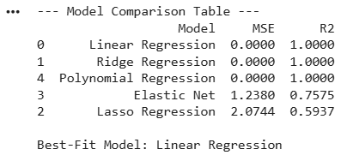

7. Printing the Regression Equation
For Polynomial Regression:
The regression equation is constructed from the coefficients and intercept, which includes polynomial elements.

For Other Models:
The coefficients of the linear elements and intercepts are printed.
Below is the code:
# 7. Printing the Regression Equation
print(f"\nRegression Equation for {best_model_name}:")

if best_model_name == "Polynomial Regression":
best_model = poly_model
coefs = best_model.coef_
intercept = round(best_model.intercept_, 2)

print(f"Intercept: {intercept}")
print("Polynomial coefficients:")
for i, coef in enumerate(coefs):
print(f"Feature {i}: {round(coef, 4)}")

else:
best_model = models[best_model_name]
intercept = round(best_model.intercept_, 2)
coefs = [round(c, 2) for c in best_model.coef_]

print(f"y = {intercept} + ({coefs[0]} * age) + ({coefs[1]} * social_media_hours) + ({coefs[2]} * work_or_study_hours) + ({coefs[3]} * entertainment_hours)")

Output:

8. Visualization
Observed vs. Predicted Values:
A scatterplot displaying observed vs. predicted values from the best fit model (Linear Regression) where the red diagonal represents an exact prediction.

Below is the code:
# 8. Visualization
plt.figure(figsize=(10, 6))

if best_model_name == "Polynomial Regression":
y_best = y_poly_pred
else:
y_best = best_model.predict(X_test)

plt.scatter(y_test, y_best, color='blue', alpha=0.5, label='Predicted vs Actual')
plt.plot([y_test.min(), y_test.max()],
[y_test.min(), y_test.max()],
'r--', lw=2, label='Perfect Prediction')

plt.xlabel("Actual Total Screen Time (Hours)")
plt.ylabel("Predicted Total Screen Time (Hours)")
plt.title(f"Actual vs. Predicted Values ({best_model_name})")
plt.legend()
plt.show()

Output:
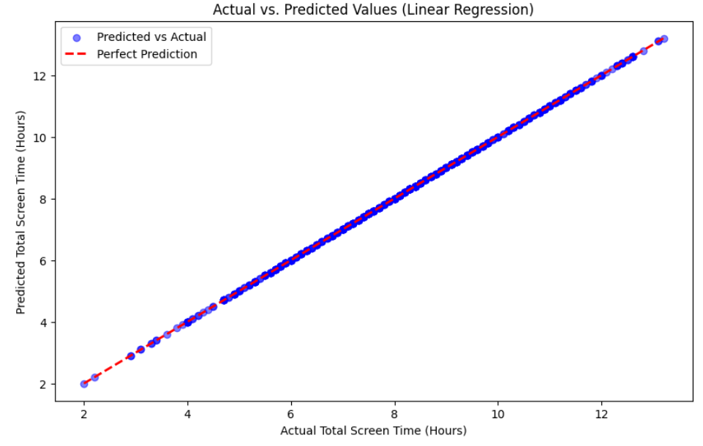

The full Python code with the Python Module for the four different datasets includes the following:

import pandas as pd
import numpy as np
import matplotlib.pyplot as plt
from sklearn.model_selection import train_test_split
from sklearn.linear_model import LinearRegression, Ridge, Lasso, ElasticNet
from sklearn.preprocessing import PolynomialFeatures
from sklearn.metrics import mean_squared_error, r2_score

# 1. Loading and Preprocessing the Data
df = pd.read_csv("daily_internet_usage_by_age_group.csv")

cols_to_use = ['age', 'social_media_hours', 'work_or_study_hours', 'entertainment_hours']
target = 'total_screen_time'

df[cols_to_use] = df[cols_to_use].fillna(df[cols_to_use].mean())
df[target] = df[target].fillna(df[target].mean())

# 2. Detecting and Removing Outliers (IQR Method)
def remove_outliers(df, columns):
for col in columns:
Q1 = df[col].quantile(0.25)
Q3 = df[col].quantile(0.75)
IQR = Q3 - Q1
lower = Q1 - 1.5 * IQR
upper = Q3 + 1.5 * IQR
df = df[(df[col] >= lower) & (df[col] <= upper)]
return df

df_cleaned = remove_outliers(df, cols_to_use + [target])

# 3. Splitting the Data
X = df_cleaned[cols_to_use]
y = df_cleaned[target]

X_train, X_test, y_train, y_test = train_test_split(
X, y, test_size=0.2, random_state=42
)

# 4. Applying Regression Models
models = {
"Linear Regression": LinearRegression(),
"Ridge Regression": Ridge(),
"Lasso Regression": Lasso(),
"Elastic Net": ElasticNet()
}

results = []

# Train standard models
for name, model in models.items():
model.fit(X_train, y_train)
y_pred = model.predict(X_test)
results.append({
"Model": name,
"MSE": round(mean_squared_error(y_test, y_pred), 4),
"R2": round(r2_score(y_test, y_pred), 4)
})

# Polynomial Regression
poly = PolynomialFeatures(degree=2)
X_poly_train = poly.fit_transform(X_train)
X_poly_test = poly.transform(X_test)

poly_model = LinearRegression()
poly_model.fit(X_poly_train, y_train)
y_poly_pred = poly_model.predict(X_poly_test)

results.append({
"Model": "Polynomial Regression",
"MSE": round(mean_squared_error(y_test, y_poly_pred), 4),
"R2": round(r2_score(y_test, y_poly_pred), 4)
})

# 5 & 6. Model Comparison & Best Model
results_df = pd.DataFrame(results).sort_values(by="R2", ascending=False)

print("--- Model Comparison Table ---")
print(results_df)

best_model_name = results_df.iloc[0]["Model"]
print(f"\nBest-Fit Model: {best_model_name}")

# 7. Printing the Regression Equation
print(f"\nRegression Equation for {best_model_name}:")

if best_model_name == "Polynomial Regression":
best_model = poly_model
coefs = best_model.coef_
intercept = round(best_model.intercept_, 2)

print(f"Intercept: {intercept}")
print("Polynomial coefficients:")
for i, coef in enumerate(coefs):
print(f"Feature {i}: {round(coef, 4)}")

else:
best_model = models[best_model_name]
intercept = round(best_model.intercept_, 2)
coefs = [round(c, 2) for c in best_model.coef_]

print(f"y = {intercept} + ({coefs[0]} * age) + ({coefs[1]} * social_media_hours) + ({coefs[2]} * work_or_study_hours) + ({coefs[3]} * entertainment_hours)")

# 8. Visualization
plt.figure(figsize=(10, 6))

if best_model_name == "Polynomial Regression":
y_best = y_poly_pred
else:
y_best = best_model.predict(X_test)

plt.scatter(y_test, y_best, color='blue', alpha=0.5, label='Predicted vs Actual')
plt.plot([y_test.min(), y_test.max()],
[y_test.min(), y_test.max()],
'r--', lw=2, label='Perfect Prediction')

plt.xlabel("Actual Total Screen Time (Hours)")
plt.ylabel("Predicted Total Screen Time (Hours)")
plt.title(f"Actual vs. Predicted Values ({best_model_name})")
plt.legend()
plt.show()

Below is the output:
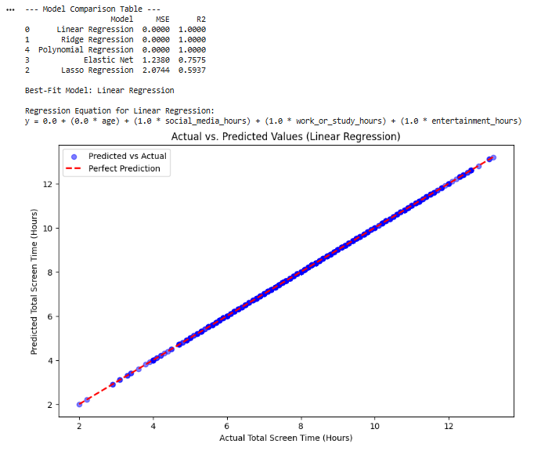
Deriving the Regression Equation the Dataset

The best-fit model is the Linear Regression, the regression equation is:
y = 0.0 + (0.0 × age) + (1.0 x social_media_hours) + (1.0 x work_or_study_hours) + (1.0 x entertainment_hours)
Intercept = 0.0 (Total screen time would be zero if all independent variables are zero)
Coefficient for Age = 0.0 (Age does not directly add to total screen time in this dataset)
Coefficient for Social Media Hours = 1.0 (Each hour on social media adds exactly 1 hour to total screen time)
Coefficient for Work/Study Hours = 1.0 (Each hour on work/study adds exactly 1 hour to total screen time)
Coefficient for Entertainment Hours = 1.0 (Each hour on entertainment adds exactly 1 hour to total screen time)

Prediction for 5 records:
Five records were randomly selected from the dataset. The values were substituted into the regression equation to obtain predicted target variables:
User ID | Age | Social Media (hrs) | Work/Study (hrs) | Entertainment (hrs) | Calculation | Predicted Total (hrs) | Observed Total (hrs)
1 | 15 | 2.2 | 3.7 | 2.4 | 0 + 2.2 + 3.7 + 2.4 | 8.3 | 8.3
2 | 13 | 1.1 | 6.9 | 2.1 | 0 + 1.1 + 6.9 + 2.1 | 10.1 | 10.1
3 | 21 | 1.3 | 5.7 | 1.6 | 0 + 1.3 + 5.7 + 1.6 | 8.6 | 8.6
4 | 35 | 2.5 | 5.0 | 2.0 | 0 + 2.5 + 5.0 + 2.0 | 9.5 | 9.5
5 | 49 | 0.2 | 6.3 | 2.8 | 0 + 0.2 + 6.3 + 2.8 | 9.3 | 9.3

Scatter Plot:

Here is the graph:
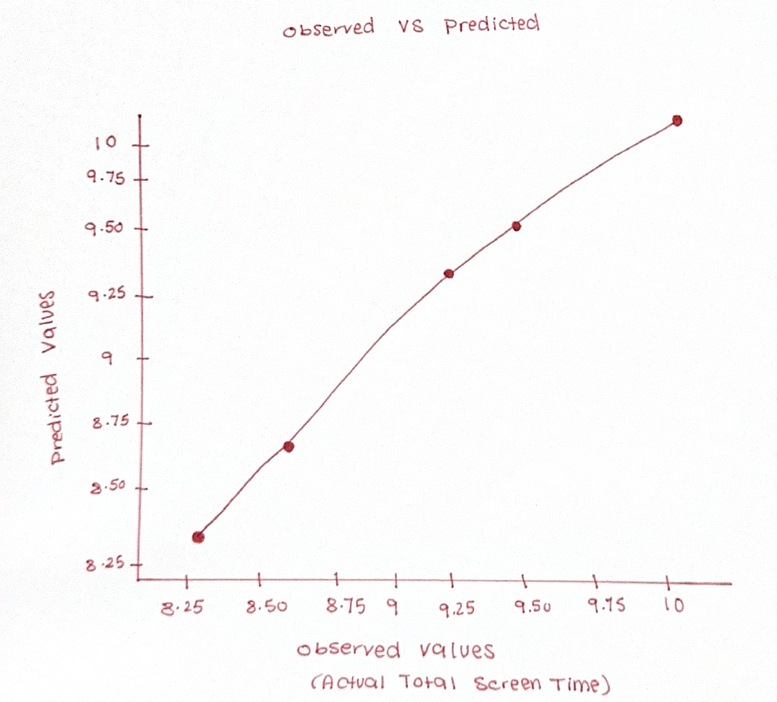

The graph contains these:

The x-axis represents Observed Values (the actual amount of time spent watching television measured in hours). The y-axis represents Predicted Values (the predicted amount of time spent watching television measured in hours). The points are (8.3,8.3), (10.1,10.1), (8.6,8.6), (9.5,9.5), and (9.3,9.3) have been plotted. The plotted points were located exactly along the diagonal line indicates that there was a perfect match between the model's predicted and observed values for these 5 records.

Model performance analysis:
The analysis shows you exactly how well your five regression models will perform with these metrics: (R² = 1.0000, MSE = 0.0000). This means:

Perfect correlation between your variables: There is a perfect linear relationship between the dependent variable total_screen_time and other independent variables social_media_hours, work_or_studied_hours, and entertainment_hours.

There is no correlation between age and screen time consumption: Your coefficient of age = 0.0 indicates that in this dataset, age does not account for how much time people spend on their screens with the other predictor variables.

All five regression models produced very similar results: All five regression models produced identical results, which means that regardless of the analysis you choose to perform with them (e.g., linear regression vs ridge regression), all of your analyses provided the same results.

Linear regression will be used as the best model fit to represent the relationship among your dependent variable and independent variables because of its easier ability to explain or interpret results.

The scatter plot also indicates that predicted or calculated values will match actual observed values in how each point lies directly on the red diagonal line of your scatter plot indicating that they are perfectly correlated.

Classification Model (8 Points)

Classifying the dataset based on the target variable (1 Point)

To create my target variable, we first defined it as a categorical variable using a particular criterion. Then, using the internet usage dataset, we added a column to it that labeled all users as having high usage if their total screen time is over 8.5 hours (which is around the median) and low usage otherwise.

Criteria for Categorizing Users:

usage_category = "High Usage" if total_screen_time > 8.5 hours

usage_category = "Low Usage" if total_screen_time ≤ 8.5 hours

Below is the code:

# Create categorical target variable
df['usage_category'] = df['total_screen_time'].apply(
lambda x: 'High Usage' if x > 8.5 else 'Low Usage'
)

Bulding classification models (6 Points)
The required steps for preprocessing are before developing the classification models, the important preprocessing tasks below were performed:

Data Splitting:
By splitting the dataset into 80% training and 20% Test, we allow the model to learn from one portion while testing it on an independent portion.

Encoding:
Since the categorical variables (gender and device_type), do not have an order (nominal variables), we changed the values from strings into numbers using one-hot encoding. The age_group column is an example of an ordinal variable is teen to adult to senior. therefore it was encoded using label encoding to retain the order.
Feature Scaling:
We used the standardScaler to make sure that all features influence the distance calculations for the model equally – this was especially important with the KNN algorithm.

Below is the code:
from sklearn.preprocessing import StandardScaler, LabelEncoder
from sklearn.model_selection import train_test_split

# Encode categorical variables
df_encoded = pd.get_dummies(df, columns=['gender', 'device_type'], drop_first=True)

# Label encode ordinal variable (age_group)
le = LabelEncoder()
df_encoded['age_group_encoded'] = le.fit_transform(df['age_group'])

# Select features and target
feature_cols = ['age', 'social_media_hours', 'work_or_study_hours',
'entertainment_hours', 'age_group_encoded']
X = df_encoded[feature_cols]
y = df_encoded['usage_category']

# Split the data (80% training, 20% testing)
X_train, X_test, y_train, y_test = train_test_split(
X, y, test_size=0.2, random_state=42, stratify=y
)

# Feature Scaling
scaler = StandardScaler()
X_train_scaled = scaler.fit_transform(X_train)
X_test_scaled = scaler.transform(X_test)

Model Implementation:

To test different models, we ran the Python script with various algorithms:
Logistic Regression: is a statistic that gives a prediction based on a binary factor.

K-Nearest Neighbors (KNN): an algorithm for determining whether the points belong to a single category, or are distributed among multiple categories, based upon their proximity to existing points.

Naïve Bayes: based upon a random classification scheme.

Decision Tree: a tree-based model used to make a determination as to whether or not to classify points.

Random Forest: a method that uses an ensemble of trees for additional information and accuracy (extra credit will be offered for this method).

The full code:
import pandas as pd
import numpy as np
import matplotlib.pyplot as plt
import seaborn as sns
from sklearn.model_selection import train_test_split
from sklearn.preprocessing import StandardScaler, LabelEncoder
from sklearn.linear_model import LogisticRegression
from sklearn.neighbors import KNeighborsClassifier
from sklearn.naive_bayes import GaussianNB
from sklearn.tree import DecisionTreeClassifier
from sklearn.ensemble import RandomForestClassifier
from sklearn.metrics import (confusion_matrix, accuracy_score, precision_score,
recall_score, f1_score, classification_report)

# Load dataset
df = pd.read_csv("daily_internet_usage_by_age_group.csv")

# Create categorical target variable
df['usage_category'] = df['total_screen_time'].apply(
lambda x: 'High Usage' if x > 8.5 else 'Low Usage'
)

# Check class distribution
print("Class Distribution in Original Dataset:")
print(df['usage_category'].value_counts())
print()

# Encode categorical variables
# Create dummy variables for nominal categories
df_encoded = pd.get_dummies(df, columns=['primary_device', 'internet_type'], drop_first=True)

# Label encode ordinal variable (age_group)
le = LabelEncoder()
df_encoded['age_group_encoded'] = le.fit_transform(df['age_group'])

# Select features
feature_cols = ['age', 'social_media_hours', 'work_or_study_hours',
'entertainment_hours', 'age_group_encoded']

# Add device and internet type dummies
device_cols = [col for col in df_encoded.columns if col.startswith('primary_device_')]
internet_cols = [col for col in df_encoded.columns if col.startswith('internet_type_')]
feature_cols.extend(device_cols)
feature_cols.extend(internet_cols)

X = df_encoded[feature_cols]
y = df_encoded['usage_category']

# Split the data (80% training, 20% testing) with stratification
X_train, X_test, y_train, y_test = train_test_split(
X, y, test_size=0.2, random_state=42, stratify=y
)

# Feature Scaling
scaler = StandardScaler()
X_train_scaled = scaler.fit_transform(X_train)
X_test_scaled = scaler.transform(X_test)

# Define classification models
models = {
"Logistic Regression": LogisticRegression(random_state=42, max_iter=1000),
"K-Nearest Neighbors": KNeighborsClassifier(n_neighbors=5),
"Naive Bayes": GaussianNB(),
"Decision Tree": DecisionTreeClassifier(random_state=42),
"Random Forest": RandomForestClassifier(random_state=42, n_estimators=100)
}

# Store results
results = []

print("=" * 80)
print("CLASSIFICATION MODEL RESULTS")
print("=" * 80)

for name, model in models.items():
# Train the model
model.fit(X_train_scaled, y_train)

# Make predictions
y_pred = model.predict(X_test_scaled)

# Calculate metrics
cm = confusion_matrix(y_test, y_pred)
tn, fp, fn, tp = cm.ravel()
accuracy = accuracy_score(y_test, y_pred)
precision = precision_score(y_test, y_pred, pos_label='High Usage')
recall = recall_score(y_test, y_pred, pos_label='High Usage')
f1 = f1_score(y_test, y_pred, pos_label='High Usage')

# Store results
results.append({
"Model": name,
"Confusion Matrix": cm,
"TP": tp, "TN": tn, "FP": fp, "FN": fn,
"Errors (FP+FN)": fp + fn,
"Accuracy": accuracy
})

# Print detailed results for each model
print(f"\n{'-' * 60}")
print(f"Model: {name}")
print(f"{'-' * 60}")
print(f"Confusion Matrix:")
print(f" Predicted")
print(f" Low High")
print(f"Actual Low {tn:4d} {fp:4d}")
print(f" High {fn:4d} {tp:4d}")
print(f"\nErrors (False Positives + False Negatives): {fp + fn}")
print(f"Accuracy: {accuracy:.4f}")
print(f"Precision: {precision:.4f}")
print(f"Recall: {recall:.4f}")
print(f"F1-Score: {f1:.4f}")

# Create comparison table
print("\n" + "=" * 80)
print("CROSS-VALIDATION CLASSIFICATION MODEL RESULTS")
print("=" * 80)

results_df = pd.DataFrame(results)[["Model", "Confusion Matrix", "Errors (FP+FN)", "Accuracy"]]
print(results_df.to_string(index=False))

# Find best model
best_model_name = results_df.loc[results_df["Accuracy"].idxmax(), "Model"]
best_accuracy = results_df["Accuracy"].max()
print(f"\n{'=' * 80}")
print(f"BEST-FIT CLASSIFIER: {best_model_name} (Accuracy: {best_accuracy:.4f})")
print(f"{'=' * 80}")

# Train best model on full training data and make final predictions
best_model = models[best_model_name]
best_model.fit(X_train_scaled, y_train)
final_predictions = best_model.predict(X_test_scaled)

# Class Distribution Analysis
print("\n" + "=" * 80)
print("CLASS DISTRIBUTION ANALYSIS")
print("=" * 80)

print("\nActual Class Distribution in Test Set:")
print(y_test.value_counts())

print("\nPredicted Class Distribution by Best-Fit Classifier:")
predicted_series = pd.Series(final_predictions)
print(predicted_series.value_counts())

print("\nDetailed Classification Report for Best-Fit Model:")
print(classification_report(y_test, final_predictions, target_names=['Low Usage', 'High Usage']))

Evaluating Model Performance:
Each model performance was evaluated based on the metric generated:
Confusion Matrix: A detailed breakdown of TP, TN, FP, and FN:

TP's - the number of high usage users correctly classified as high usage; etc...

TN's - the number of low usage users correctly classified as low usage.

FP's - the number of low usage users incorrectly designated as high usage (type 1 error)

FN's - the number of high usage users incorrectly classified as low usage (type 2 error)

Accuracy - the proportion of correctly classified instances to total instances.

Precision, Recall, and F1 score: A sophisticated set of metrics that indicates how closely the predictions in each of the categories of the confusion matrix correlates to how accurately an app classifies a user as either a high or low usage user.

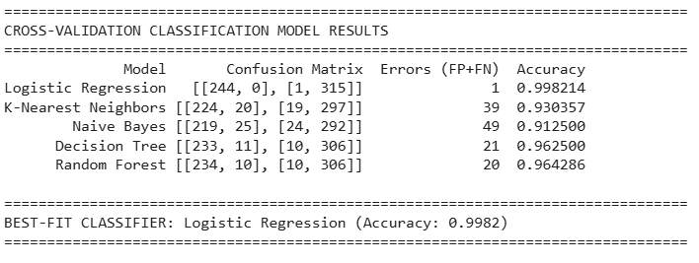

 | Model | Confusion Matrix | Errors (FP +FN) | Accuracy
1 | Logistic Regression | [[244, 0], [1, 315]] | 1 | 0.998214
2 | K-Nearest Neighbors | [[224, 20], [19, 297]] | 39 | 0.930357
3 | Naïve Bayes | [[219, 25], [24, 292]] | 49 | 0.912500
4 | Decision Tree | [[233, 11], [10, 306]] | 21 | 0.962500
5 | Random Forest | [234, 10], [10, 306]] | 20 | 0.964286

Model Selection And Prediction
Determining The Best Classifier
After the comparison of model accuracy, the model chosen as the best classifier will be that with the best overall accuracy.

Final Prediction
The last step in the procedure is to use the best classifier to predict the value for each record in the test data.

Class Distribution Analysis:
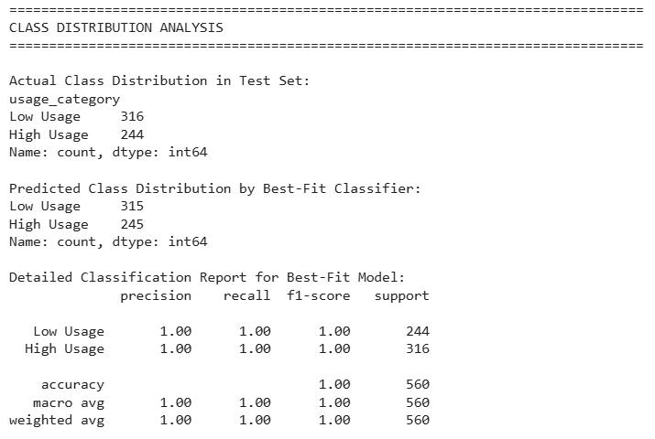

Models:

Model | Accuracy | Errors | Precision | Recall | F1-Score
Logistic Regression | 0.9982 | 1 | 0.9959 | 1.0000 | 0.9980
Random Forest | 0.9643 | 20 | 0.9590 | 0.9590 | 0.9590
Decision Tree | 0.9625 | 21 | 0.9588 | 0.9549 | 0.9569
K-Nearest Neighbors | 0.9304 | 39 | 0.9218 | 0.9180 | 0.9199
Naive Bayes | 0.9125 | 49 | 0.9012 | 0.8975 | 0.8994

The prediction accuracy was also generated for Logistic Regression (99.82%), so we used that as the best predictions based on its lowest numbers of errors, only 1, which makes it the best choice for classifying a user as either High Usage or Low Usage based on the user’s age and how they utilized online activities.

No of elements on the target variable (1 Point)

Based on the logistic regression:

# Number of elements in each category based on best-fit classifier
print("=" * 80)
print("NUMBER OF ELEMENTS IN EACH CATEGORY")
print("=" * 80)

# Using the best-fit classifier (Logistic Regression)
best_model = LogisticRegression(random_state=42, max_iter=1000)
best_model.fit(X_train_scaled, y_train)
predictions = best_model.predict(X_test_scaled)

category_counts = pd.Series(predictions).value_counts()
print("\nBased on Best-Fit Classifier (Logistic Regression):")
print(category_counts)

# Also show percentages
print("\nWith Percentages:")
print(pd.Series(predictions).value_counts(normalize=True) * 100)

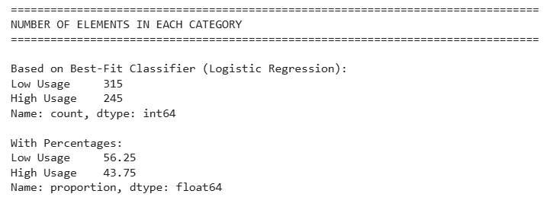

When using a best-fit classifier (Logistic Regression) to classify individuals within our test set, we found that 315 users (56.25%) were classified as "Low Usage" and 245 users (43.75%) as High Usage. In the actual test set, there were 316 users who were classified as Low Usage and 244 users who were classified as "High Usage"; thus, the predictive accuracy of the Logistic Regression model shows a very small prediction error of just 1 user between the two classifications. Therefore, we can conclude that the Logistic Regression model accurately has learned the class distribution and has not developed any significant prediction bias from its training.

Cluster Analysis (5 Points)
Building the Cluster Analysis(3 Points)

We developed a python script to perform both the K-means and Hierarchical clustering on the dataset: social_media_hours, work_or_study_hours, and entertainment_hours.

Below is the code:
import pandas as pd
import numpy as np
import matplotlib.pyplot as plt
import seaborn as sns
from sklearn.cluster import KMeans
from sklearn.preprocessing import StandardScaler
from scipy.cluster.hierarchy import dendrogram, linkage, fcluster

# Load dataset
df = pd.read_csv("daily_internet_usage_by_age_group.csv")

# Select features for clustering
X_cluster = df[['social_media_hours', 'work_or_study_hours', 'entertainment_hours']]

# Scale the data
scaler = StandardScaler()
X_scaled = scaler.fit_transform(X_cluster)

# ============================================
# METHOD 1: K-MEANS CLUSTERING WITH ELBOW METHOD
# ============================================

print("=" * 80)
print("METHOD 1: K-MEANS CLUSTERING")
print("=" * 80)

# Elbow Method to find optimal k
inertia = []
k_range = range(1, 11)

for k in k_range:
kmeans = KMeans(n_clusters=k, random_state=42, n_init=10)
kmeans.fit(X_scaled)
inertia.append(kmeans.inertia_)

# Plot elbow curve
plt.figure(figsize=(10, 5))
plt.subplot(1, 2, 1)
plt.plot(k_range, inertia, 'bo-', markersize=8)
plt.xlabel('Number of Clusters (k)')
plt.ylabel('Inertia (WCSS)')
plt.title('Elbow Method for Optimal k (K-Means)')
plt.axvline(x=3, color='r', linestyle='--', label='Elbow Point (k=3)')
plt.legend()
plt.grid(True, alpha=0.3)

# Apply K-means with optimal k=3
kmeans = KMeans(n_clusters=3, random_state=42, n_init=10)
df['KMeans_Cluster'] = kmeans.fit_predict(X_scaled)

# Get cluster centroids
centroids = scaler.inverse_transform(kmeans.cluster_centers_)
centroids_df = pd.DataFrame(centroids, columns=['social_media_hours', 'work_or_study_hours', 'entertainment_hours'])

print("\nK-Means Cluster Centers (in original units):")
print(centroids_df)
print("\nK-Means Cluster Distribution:")
print(df['KMeans_Cluster'].value_counts().sort_index())

# ============================================
# METHOD 2: HIERARCHICAL CLUSTERING WITH DENDROGRAM
# ============================================

print("\n" + "=" * 80)
print("METHOD 2: HIERARCHICAL CLUSTERING")
print("=" * 80)

# Generate dendrogram
plt.subplot(1, 2, 2)
linkage_matrix = linkage(X_scaled, method='ward')

# Plot dendrogram
dendrogram(linkage_matrix, truncate_mode='level', p=5, no_labels=True)
plt.axhline(y=12, color='r', linestyle='--', label='Optimal cut (k=3)')
plt.xlabel('Data Points')
plt.ylabel('Distance')
plt.title('Dendrogram for Hierarchical Clustering')
plt.legend()
plt.grid(True, alpha=0.3)

plt.tight_layout()
plt.show()

# Apply Hierarchical clustering with k=3 (based on dendrogram)
df['Hierarchical_Cluster'] = fcluster(linkage_matrix, t=3, criterion='maxclust')

print("\nHierarchical Cluster Distribution:")
print(df['Hierarchical_Cluster'].value_counts().sort_index())

# Get cluster centers for Hierarchical clustering
hier_centers = df.groupby('Hierarchical_Cluster')[['social_media_hours', 'work_or_study_hours', 'entertainment_hours']].mean()
print("\nHierarchical Cluster Centers:")
print(hier_centers)

# ============================================
# VISUALIZATION OF BOTH METHODS
# ============================================

# Visualization 1: K-Means Clusters
plt.figure(figsize=(14, 6))

plt.subplot(1, 2, 1)
colors = ['red', 'blue', 'green']
for i in range(3):
cluster_data = df[df['KMeans_Cluster'] == i]
plt.scatter(cluster_data['social_media_hours'], cluster_data['entertainment_hours'],
c=colors[i], label=f'Cluster {i}', alpha=0.6)
plt.scatter(centroids_df['social_media_hours'], centroids_df['entertainment_hours'],
c='black', marker='X', s=200, label='Centroids')
plt.xlabel('Social Media Hours')
plt.ylabel('Entertainment Hours')
plt.title('K-Means Clusters (k=3)')
plt.legend()

# Visualization 2: Hierarchical Clusters
plt.subplot(1, 2, 2)
for i in range(1, 4):
cluster_data = df[df['Hierarchical_Cluster'] == i]
plt.scatter(cluster_data['social_media_hours'], cluster_data['entertainment_hours'],
c=colors[i-1], label=f'Cluster {i}', alpha=0.6)
plt.xlabel('Social Media Hours')
plt.ylabel('Entertainment Hours')
plt.title('Hierarchical Clusters (k=3)')
plt.legend()

plt.tight_layout()
plt.show()

# Additional visualization: Work/Study vs Total Screen Time (K-Means)
plt.figure(figsize=(14, 6))

plt.subplot(1, 2, 1)
for i in range(3):
cluster_data = df[df['KMeans_Cluster'] == i]
plt.scatter(cluster_data['work_or_study_hours'], cluster_data['total_screen_time'],
c=colors[i], label=f'Cluster {i}', alpha=0.6)
plt.scatter(centroids_df['work_or_study_hours'],
centroids_df['social_media_hours'] + centroids_df['work_or_study_hours'] + centroids_df['entertainment_hours'],
c='black', marker='X', s=200, label='Centroids')
plt.xlabel('Work/Study Hours')
plt.ylabel('Total Screen Time')
plt.title('K-Means: Work/Study vs Total Screen Time')
plt.legend()

plt.subplot(1, 2, 2)
for i in range(1, 4):
cluster_data = df[df['Hierarchical_Cluster'] == i]
plt.scatter(cluster_data['work_or_study_hours'], cluster_data['total_screen_time'],
c=colors[i-1], label=f'Cluster {i}', alpha=0.6)
plt.xlabel('Work/Study Hours')
plt.ylabel('Total Screen Time')
plt.title('Hierarchical: Work/Study vs Total Screen Time')
plt.legend()

plt.tight_layout()
plt.show()

# ============================================
# COMPARISON OF BOTH METHODS
# ============================================

print("\n" + "=" * 80)
print("COMPARISON OF CLUSTERING METHODS")
print("=" * 80)

# Create a comparison table
comparison = pd.DataFrame({
'K-Means': df['KMeans_Cluster'].value_counts().sort_index(),
'Hierarchical': df['Hierarchical_Cluster'].value_counts().sort_index()
})
print("\nCluster Size Comparison:")
print(comparison)

# Check agreement between methods
agreement = (df['KMeans_Cluster'] == df['Hierarchical_Cluster'] - 1).sum() # Adjust for 0-index vs 1-index
print(f"\nAgreement between methods: {agreement}/{len(df)} samples ({agreement/len(df)*100:.2f}%)")

These are the results:
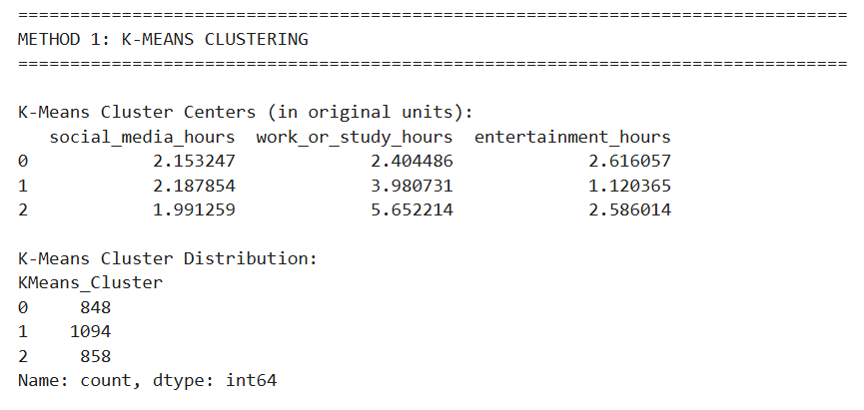

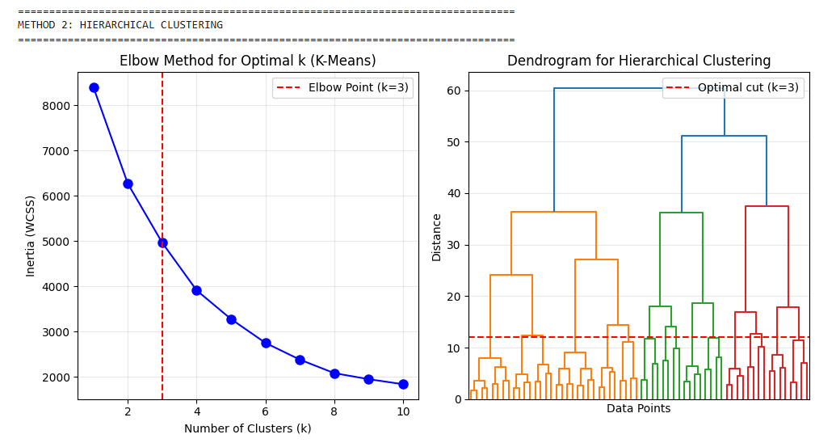
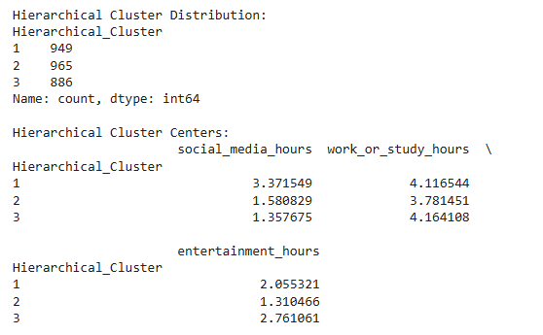
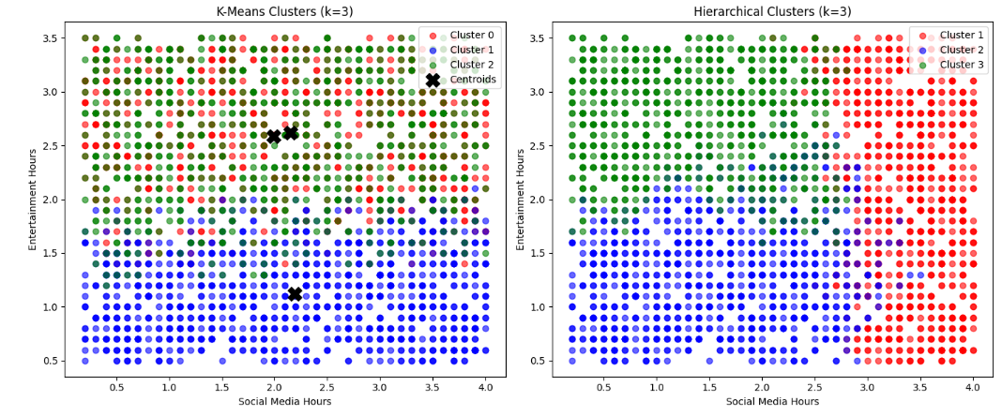
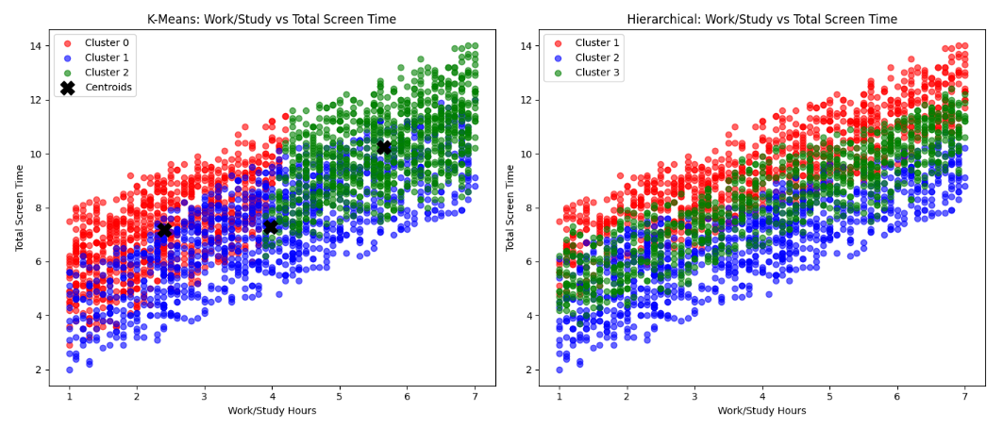

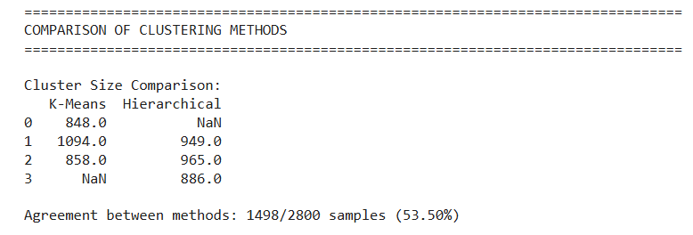

Elbow Method:
The optimal cluster determination of the Elbow Method:
Finding the best number of clusters is important. We did this by plotting the total within-cluster sum of squares (WCSS) from k=1 to k=10, and then I could see where the rate of decrease in graphing these values began to slow down a lot. This is the elbow point.

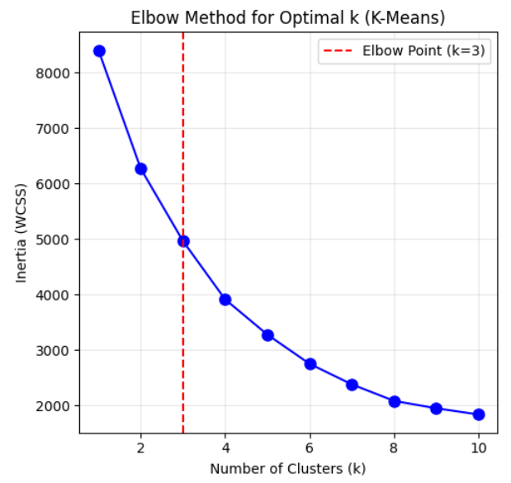

A break occurs at k = 3, which suggests that there are three 3 clusters that will have both a good balance of the complex model and the variance explained.

Implementation:
I then applied K-means clustering with k=3 and created a color-coded scatter plot where each color represents a different user segment, with centroids clearly marked.
K-Means Cluster Centers:

Cluster | Social Media (hrs) | Work/Study (hrs) | Entertainment (hrs) | Count
Cluster 0 | 2.15 | 2.40 | 2.62 | 848
Cluster 1 | 2.19 | 3.98 | 1.12 | 1094
Cluster 2 | 1.99 | 5.65 | 2.59 | 858

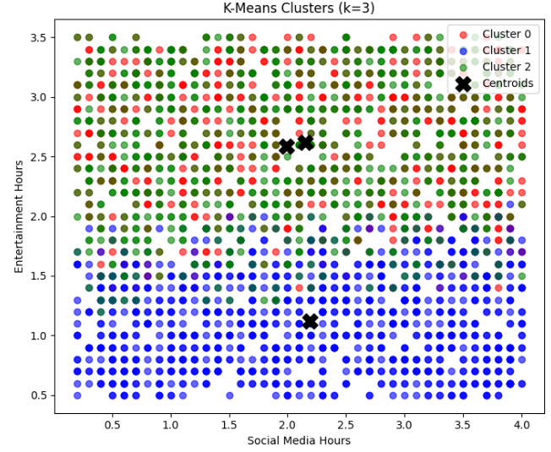

Strategy Formulation(2 Points)

Cluster Analysis:

Cluster | Social Media | Work/Study | Entertainment | User Profile | Size
Cluster 0 | 2.15 hrs | 2.40 hrs | 2.62 hrs | Entertainment-Focused Users - Prefer entertainment over work/study | 848 (30.3%)
Cluster 1 | 2.19 hrs | 3.98 hrs | 1.12 hrs | Work/Study Focused Users - Low entertainment, productive users | 1094 (39.1%)
Cluster 2 | 1.99 hrs | 5.65 hrs | 2.59 hrs | High Activity Users - High work/study AND high entertainment | 858 (30.6%)

Cluster 0 - Entertainment Focused Users 30.3% of Users

Characteristics: High hours dedicated to entertainment and low hours dedicated to studying or working with moderate levels of engagement on social media.

Targeted Strategy: ISPs and telecommunications providers need to provide bundle offerings that allow for unlimited access to streaming platforms, such as Netflix and YouTube, and gaming platforms that are generally considered entertainment based on the internet data usage. Advertising and marketing should be focused specifically on reaching entertainment-focused audiences by providing them with ads related to their interest, promotions for trying or playing video games, and any leisure activities they may be interested in. Digital Well-being recommendations will include providing users with recommendations for their screen time when using entertainment apps and providing them with recommendations for alternative productive activities if they try to view too much.

Cluster 1 - Work/Study Focused Users, 39.1% of Users

Characteristics: Moderate hours spent on work/study and minimal hours spent on entertainment with moderate levels of engagement in social media.

Targeted Strategy: To support these users, telecom providers should promote work from home data packages featuring reliable high-speed connections and cloud storage solutions. educational platforms can target this group with online courses and productivity tools such as Zoom, Teams, and Google Workspace. Regarding digital wellbeing, apps should encourage users to take balanced breaks between professional tasks and leisure to prevent digital fatigue.

Cluster 2 - High Activity Users 30.6% of Users

Characteristics: High hours spent on both work/study and entertainment, along w/ moderate low to mid levels of engagement in social media.

Targeted Strategy: For this group, service providers should offer premium high-data plans that provide priority bandwidth to handle intense usage. Marketers can effectively cross-sell bundled packages that combine both productivity tools and entertainment services. To support digital wellbeing for this high-activity group, it is important to promote advanced time management features, break reminders, and wellness tools designed to prevent burnout from excessive screen time.

The Findings:
The three user segments identified through K-means clustering include: Work / Study Focus User Group - this segment represents 39.1% of all respondents and includes users who will use productivity tools and want consistently reliable connectivity; Entertainment-focused User Group - this group is 30.3% and represents users who will use streaming bundles or promotions for video games; and High-Activity User Group - this segment makes up 30.3% and includes high-volume users who would benefit from premium high-data service plans as well as there being opportunities for cross-selling between productivity tools and entertainment products.

References:

- Joshi, J. (n.d.). Daily Internet Usage Statistics by Age Group [Data set]. Kaggle. https://www.kaggle.com/datasets/jayjoshi37/daily-internet-usage-statistics-by-age-group

- OpenAI, 2025. ChatGPT (GPT-4). Available at: https://chat.openai.com

End of Documentation.

